Atom Project

In class we are learning that EVERYTHING – solids, liquids, and gases – are made of matter. Matter is made up of atoms and molecules – but what does that really mean? This project will help you understand how over time we have gradually learned more about these things called atoms.

Atoms as we now know them were not discovered all at once by one incredibly genius scientist, but we have learned their characteristics little by little.

Your mission is to create a model (or fantastic visual representation) of the atom, according to the ideas of a specific scientist in history as HE understood it. You will need to include the following for your project:

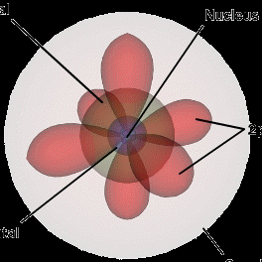
- Name of the scientist
- Birth and death years of the scientist
- Model/visual of the atom
- Description of the key features of the model
(one typed paragraph in your own words)

Each of you will be assigned a specific scientist in class for making your model. Circle the scientist that you are assigned from the following list:

Werner Heisenberg
Democritus
Joseph John Thomson

Ernest Rutherford
Niels Bohr
James Chadwick

You will be graded on completion (you have everything included), accuracy of the model (that your model shows correctly what that scientist thought about atoms), and presentation (neatness).

The project will be due in class on

Here are some helpful websites to get you started:
http://www.usoe.k12.ut.us/CURR/SCIENCE/core/7thgrd/sciber7/matter/html/GRANDPA.HTM
http://www.csmate.colostate.edu/cltw/cohortpages/viney/atomhistory.html
http://www.emsb.qc.ca/laurenhill/science/models.html
http://www.fordhamprep.org/gcurran/sho/sho/lessons/lesson32.htm

