**Name Period**

1. When scientists were developing theories about the atom, they… (circle all that apply)

1. Used ideas from other scientists to make a new theory.
2. Realized that everything that all the theories before them were completely wrong.
3. Used microscopes to look inside the atoms.
4. Made indirect observations.

2. Carbon atoms have 6 electrons, 6 protons, and 6 neutrons. In the box to the right, draw a carbon atom. Draw circles with +’s for protons, -‘s for electrons, or N’s for neutrons.

3. In the boxes below, draw pictures showing the arrangement of molecules in the different phases of matter.



Solid Liquid Gas

4. What is the relationship between temperature and motion of particles?

5. How do you find the volume of an irregular solid?

6. Explain one way you could find the mass of a gas.

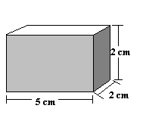7. Using your understanding of density, explain why our hot air balloons floated.

One day, you find a block of metal on the side of the road. It looks like gold! Being brilliant, you decide to figure out the density of the metal to see if it is really gold. A picture of the chunk of gold is shown to the right.

8. What is the volume of the metal block? Show your work.

9. You find the mass to be 200 g. You just figured out the volume. Use mass and volume to find the density of the metal block. Show your work.

10. The density of gold is 19 g/cm3. Is the metal you found gold? _______________

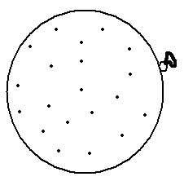Let’s say you blow up a balloon with regular air. Then you let the balloon sit outside in the sun. The balloon begins to get much warmer.

11. To the right is a picture of the original balloon. In the space below it draw the balloon after it is warmed by the sun. If there are changes in the size of the balloon, make it obvious. You can exaggerate.

Circle the correct answer:

12. Which balloon has more mass?

Room temperature balloon Balloon in the sun They are the same

13. Which balloon has more volume?

Room temperature balloon Balloon in the sun They are the same

14.Which balloon has a higher density?

Room temperature balloon Balloon in the sun They are the same

15. If you cut cheese in half forever and ever, there **would** **come a point** when you could not cut it anymore, even if you had a small enough knife and a strong enough microscope. (1 pt)

1. True
2. False

16. What are molecules? Circle all that apply. (1 pts)

1. Atoms
2. Elements
3. 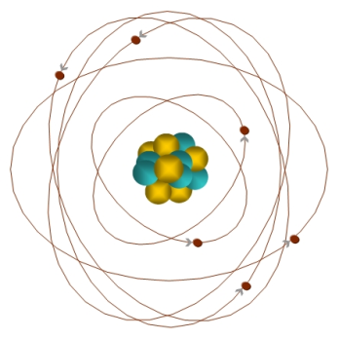Several atoms bonded together
4. The particles inside the nucleus of an atom

17. To the right is a model (picture) of an atom. Describe two ways that this model is incorrect. (2 pts)

18. What is diffusion?

19. What are the three parts to an atom, their charges and locations?



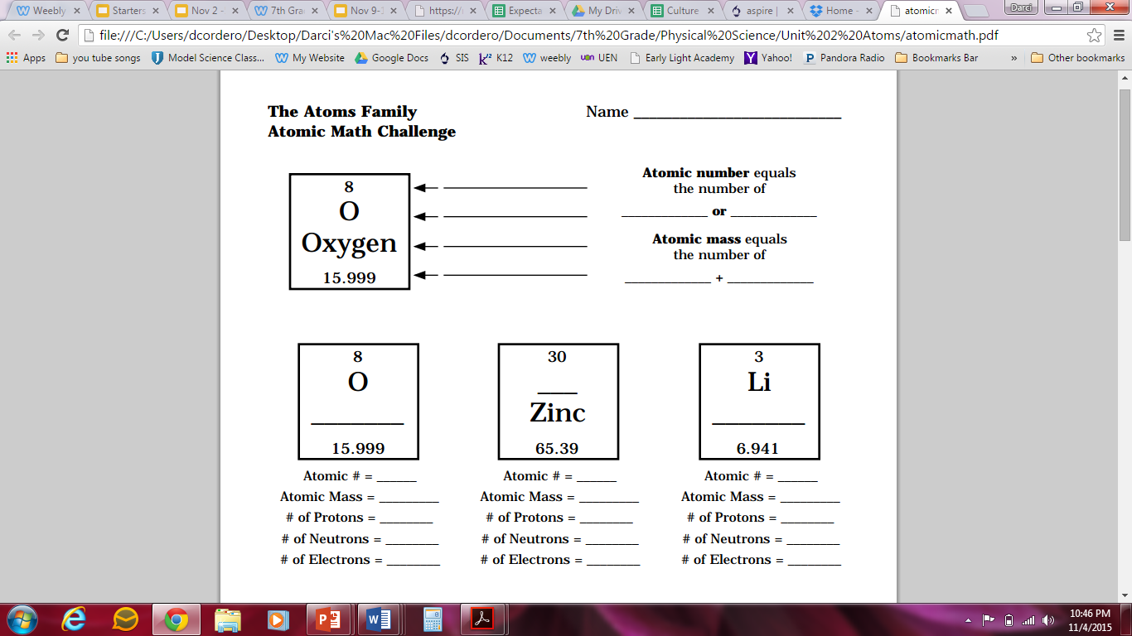

Fill in the blanks and answer the questions. You will need to use your periodic table in your planner.

